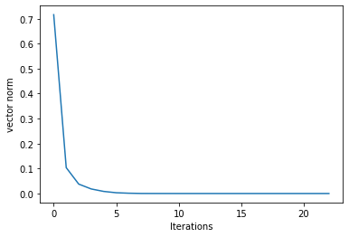

For question no Q1.iv and Q1.v we see the graph with the same nature. We are plotting a graph using vector norm of difference matrix with respect to the number of iterations we are doing.

Difference matrix is x_new – x and then we take the vector norm L2 on it. This graph represents that when vector norm is decreasing from higher value to the lower value, that means we are moving towards the 0.

When we say that x_new -x is moving towards the zero, that means our solution is converging. On the other hand when the graph shows the positive slope that means the solution is diverging, as x_new-x is increasing and we will not get the values for the variables.

In our case graph has negative slope and at point after 5th iteration we see vector norm for difference matrix is reaching to almost zero, that means our solution is converging.